A researcher wishes to try three different techniques to lower the blood pressure of individuals diagnosed with high blood pressure. The subjects are randomly assigned to three groups; the first group takes medication, the second group exercises, and the third group follows a special diet. After four weeks, the reduction in each person’s blood pressure is recorded. At *α*= 0.05, test the claim that there is no difference among the means.

Recall the Example : Lowering Blood Pressure

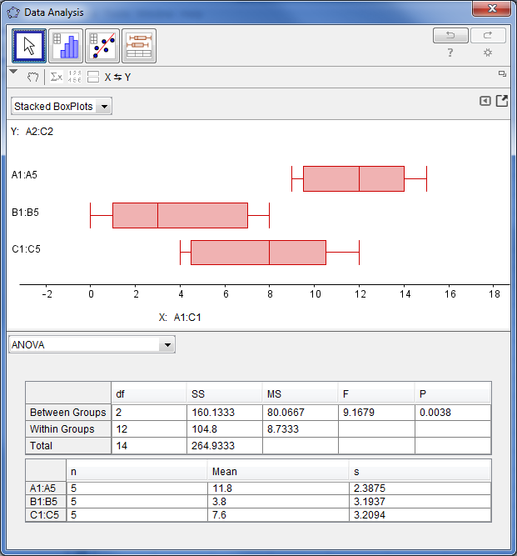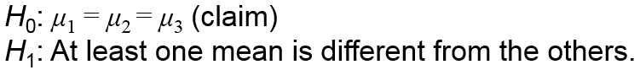

(this meant that we can conclude that at least one mean was different from the others).

**Our Step 5: Summary results were:**

There is enough evidence to reject the claim that the means are the same.

**Our One Way ANOVA test results were:**

**Since our critical value was F=3.77 and our test value was 9.1679, we rejected H0 (the null hypothesis).**

**Our hypotheses were:**

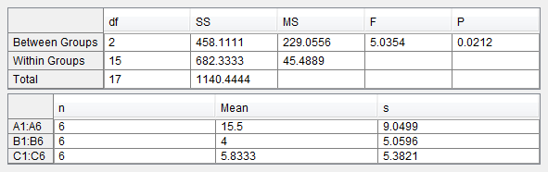

A state employee wishes to see if there is a significant difference in the number of employees at the interchanges of three state toll roads. The data are shown. At α = 0.05, can it be concluded that there is a significant difference in the average number of employees the interchanges?

**Our hypotheses were:**

Recall the Example: Toll Road Employees

(this meant that we can conclude that at least one mean was different from the others).

**Our Step 5: Summary results were:**

There is enough evidence to support the claim that at least one mean is different from the others.

**Our One Way ANOVA test results were:**

**Since our critical value was F=3.68 and our test value was F=5.04, we rejected H0 (the null hypothesis).**