Spring 2020 Soc 220 Dice Roll Sample Raw Data
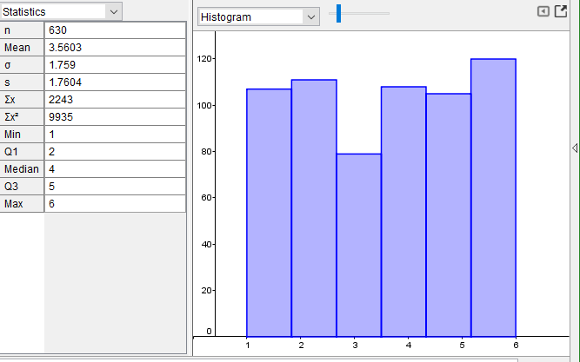
Spring Soc 220 Dice Roll Sample Means
