Chapter 6 Written Homework
Name:___________________ Instructor Name: ____________________
Learning Objectives:
a – Identify the properties of a normal distribution and a skewed distribution.
b – Find the area under the standard normal distribution, given various z-score values.
c – Find probabilities for a normally distributed variable by transforming it into a standard normal variable.
d – Find specific data values for given percentages, using the standard normal distribution.
e – Use the Central Limit Theorem to solve problems for large samples

For the problems that follow you may use the GeoGebra Probability calculator, Excel, or Table E from the textbook. In any case, you must sketch the probability question on the curve provided. Your sketch should include the horizontal-axis properly scaled and shading that accurately depicts the question being posed.

- What are the values of μ and σ in the standard normal distribution?

- For the standard normal distribution below:
a. Find $P(-1.50<z<2.50)$
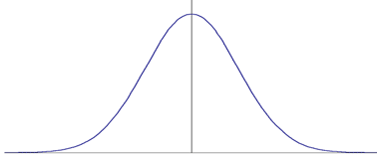
b. Explain the process you used to determine your answer.

- For the standard normal distribution below:
a. Find $P(z>1.59)$
b. Explain the process you used to determine your answer.

4. For the standard normal distribution below:
a. Find $P(z<-1.23)$
b. Explain the process you used to determine your answer.

5. The average credit card debt for college seniors is $3262.

a. If the debt is normally distributed with a standard deviation of $1100, find the probability that a randomly selected student owes less than $1500.

b. Explain the process you used to determine your answer.

- Scores on an English test are normally distributed with a mean of 33.8 and a standard deviation of 8.5.
a. Find the score that separates the top 59% from the bottom 41%.

b. Explain the process you used to determine your answer.

