Name:_______________________ Instructor:_____________________
Chapter 7 Written HW
Learning Objectives:
Identify and determine which type of sampling is being conducted given a contextual data
collection situation.
Determine the difference between a parameter and a statistic and identify when each measure would be used appropriately.
Use the Central Limit Theorem to find z-scores and probabilities given in a contextual situation.

Part A: Key Vocabulary
Use your textbook and any additional online resources to learn the vocabulary terms from chapter 7 listed below. Please define these terms and in your own words.

Central Limit Theorem

Parameter

Population

Sample

Sampling Error

Standard Error of the mean

Statistic

Convenience Sample

Random Sample

Systematic Sample

Stratified Sample

Cluster Sample

Part B: For the following portions of the homework please refer to your textbook at the end of Chapter 7 pgs 232-236.

Problem #1 Complete parts a, b, c, d, & e in the space provided below.

Problem #2 - Complete parts a & b in the space provided below.

Problem #9 - Complete parts a, b, c, & d in the space provided below.

Problem #10 – Complete parts a & b in the space provided below.

PART C: Complete the following two problems.

C1) The average yearly Medicare Hospital Insurance benefit per person was $4064 in a recent year.

a. If the benefits are normally distributed with a standard deviation of $460, find the probability that the mean benefit for a random sample of 20 patients is less than $3800.
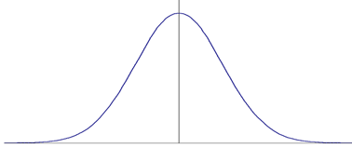

b. Explain the process you used to determine your answer.

C2) Create your own unique example of each of the following sampling types. (We covered these in the Ch 7 Sampling Pwpt (2 slide only) – recall this is the card activity that we did in class to illustrate how each sampling type is different. DO NOT USE A DECK OF CARDS AS YOUR EXAMPLES!

Note: Each Soc 220 student should have their own unique examples – when I read these – there should be NO DUPLICATES!
Convenience Sample Example

Random Sample Example

Systematic Sample Example

Stratified Sample Example

Cluster Sample Example

