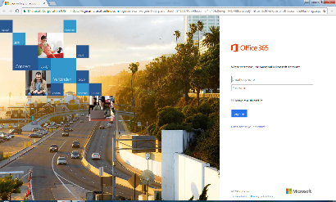
Step 1:
Open a web browser and type the following in the URL – portal.office.com
Your screen should look like Figure 1.
Figure 1
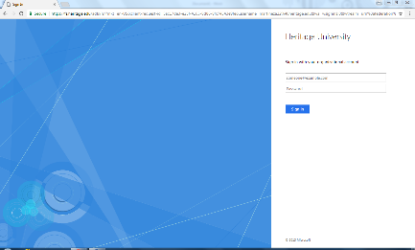
Step 2:
Enter your Heritage University email and click “Sign In” (do not enter a password).
You will be redirected to HU’s Sign In Page where you will enter your Heritage University email and password (see Figure 2).
Figure 2

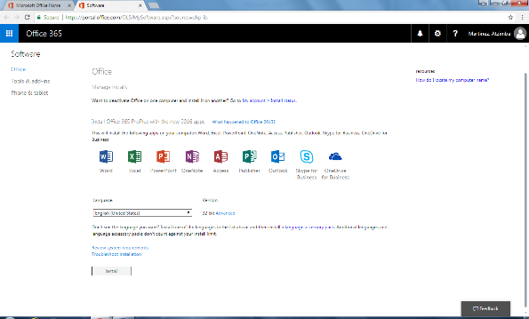
Step 3:
Once signed in, you will see this page (Figure 3):

Click “Install”

Step 4:
Follow the three steps on the screen (Figure 4).
Figure 3
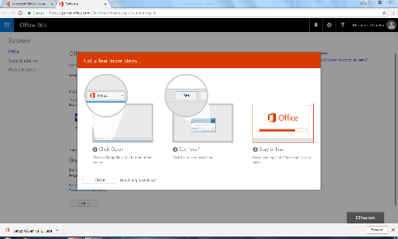

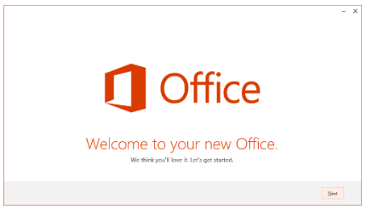
Figure 4

Step 5:
Once Office is finished loading, you will see this (Figure 5):

Click “Next” twice.
Figure 5

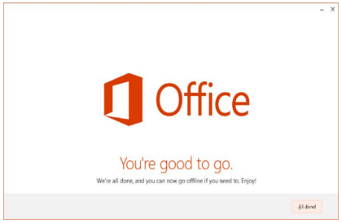
Step 6:
You will then have the option to take a tour. If you wish to take the tour, click “Take a look,” otherwise, click “No, thanks.”

Step 7:
Once you have completed the tour, or selected not to view it, the final screen will pop up (Figure 6). Click “All done.”
Figure 6

